**An Overview of How the Corona Virus affected Individual Countries from 22/01/2020 to 09/03/23.**

Reported by Lucy Pitfield – lap52, Riya Abraham – ra684, Harsha Kumar – hk425, Crystal Dias – cd644.

1. **Executive summary**

COVID -19 is an infectious disease that was first identified in 2019 in Wuhan, China. It has spread globally and has resulted in people around the world catching this severe acute respiratory illness. The main objective of this report is to analyse how the number of daily confirmed, daily recovered and daily deaths of people have changed over different periods of time across various countries.

The data was collected by the Johns Hopkins University Centre for System Science and Engineering (JHU CSSE). It launched the first global real-time coronavirus surveillance system: JHU CSSE COVID-19 dashboard. This allowed people around the world to access and view it to see the current situation of COVID-19. This system enabled data collection, data fusion logic, data curation and sharing, anomaly detection and data correction.

Throughout analysis, there were a few key outcomes that stood out. The first being for UK and US in January 2023, the overall trend was that there is a decrease in the number of daily confirmed cases as well as deaths. There could be a possible improvement in the number of cases and deaths as the years progress. Secondly for mainland China, a key result was the sudden spike in daily cases, recovery, and deaths, and the significant decrease for all three variables after that initial spike. This is due to the new rule passed by WHO to only consider numbers provided by clinics. Thirdly, a key observation in the UK was that there was large increase in daily confirmed cases in January 2022 compared to January 2021, which correlates to how infectious the omicron variant is compared to the alpha variant. Where the alpha variant has an infection rate of 70%, but compared to omicron which has an infection rate of 81%, is lower. Our fourth and final observation is on the country of Fiji. It had very seasonal spikes in cases from 2021 onwards, with the majority of the peaks occurring in the middle of summer or winter, but overall winter having a higher average of confirmed deaths and cases.

While this report was being created, we saw some irregularities in the data given. There was either missing data, or the data collection interval for each country was different. For example, China collected their data everyday whereas the UK collected their data every week. This caused a lack of data integrity, thus causing irregular data. For future improvements this can be amended, so that more accurate representations can be created of the pandemic.

1. **Introduction**

Covid-19 had a major impact on the health and wellbeing of the entire world due to its suddenness and ferocity. In this report, we will tackle the issue in a worldwide scope focusing on 4 main points: cases in the UK vs the US in January 2023, cases in Mainland China from January to March 2020, the Trend in the UK of cases during January 2021, 2022, and 2023 and how Fiji was affected differently between the summer and winter months.

The data was presented in a csv file of a particular date between 22/01/2020 and 09/03/23 with all the counties and regions in those countries recorded as unique rows. In the file was recorded the province (if provided), Country, Last update of data, confirmed cases total, Death total, Recovered cases total and latitude and longitude of the region. We decided to ignore the recovered data as it was not reported on for the whole of the study. This is because they relied on the Covid Tracking Project for the data who stopped recording the recovered cases due to a lack of data from some countries. [(https://covidtracking.com/about-data/faq#why-have-you-stopped-reporting-national-recoveries)](https://covidtracking.com/about-data/faq#why-have-you-stopped-reporting-national-recoveries)

Section 3 will discuss the patterns in cases seen between the UK and the US.

Section 4 will demonstrate the pattern of cases in Mainland China’s data in the initial stages of the pandemic, from 22 January 2020 to 1 March 2020.

Section 5 compares the daily numbers of confirmed cases, recovered cases, and of deaths in the UK for the month of January in different years.

Section 6 finishes by reviewing the change in cases between the seasons for Fiji, using typical months during winter and typical months during summer.

1. **UK VS US**

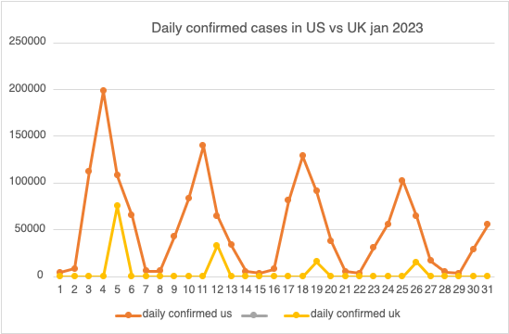

The US reported higher numbers of confirmed cases consistently than the UK. this could be because the US has a higher population than the UK therefore more cases. The highest peak in the US is 200,000 whereas the highest peak in the UK is 75,047.

The daily confirmed cases in the US and the UK show significant fluctuations throughout the month. There were peaks with a higher number of cases indicating an outbreak of the virus or increased amounts of testing on that day.

UK had some days with no reported cases which might indicate gaps in reporting. In the UK data is reported every 7 days on the weekend, whereas in the US the daily confirmed cases have been reported every day. The difference in testing and reporting strategies has a direct impact on the number of cases. Higher testing capacity can lead to higher reported case numbers, while delays in testing and reporting can lead to underestimation of actual number of cases. both countries exhibit fluctuations in daily confirmed cases over time, indicating dynamic changes in the spread of the virus and potentially reflecting changes in public health measures, testing strategies, or the emergence of new variants.

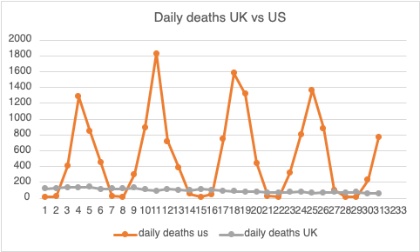

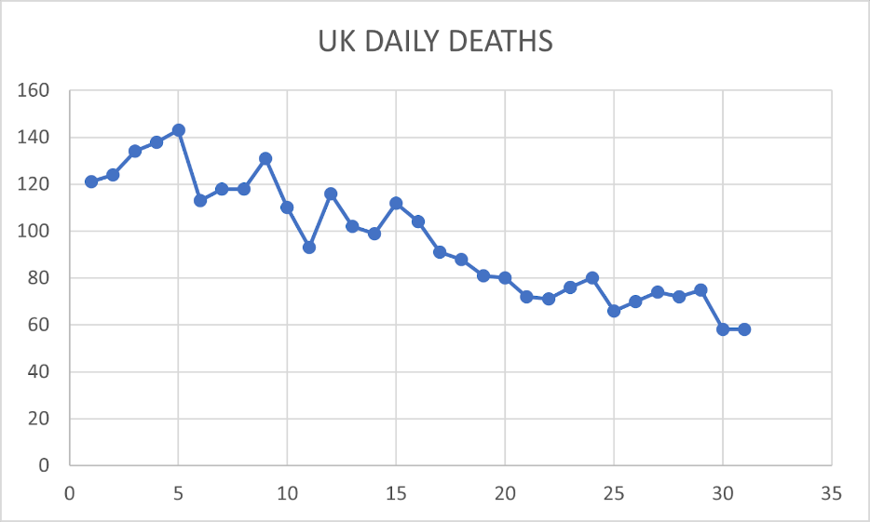

In the US, the data show fluctuations in daily deaths throughout the month, ranging from as high as 1,830 on January 11 to 17 deaths on 15 January. There are notable spikes on January 4, January 11, and January 18. The US exhibit more variation in daily death counts while the UK is more consistent with fewer extreme fluctuations.

In the US there is a spike in daily deaths between the 4th of January to 11th of January and after that, there has been a decrease in the number of deaths which suggests a potential decline in the severity of the situation.

The UK also experiences fluctuations in daily deaths, although the overall numbers are much lower compared to the US. Notable spikes include January 5, and January 11. The daily deaths in the UK decreased gradually throughout January suggesting potential improvement in the number of deaths as the year progresses.

1. 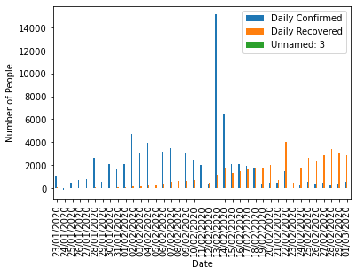**Mainland China**

Figure 1: Number of People daily being confirmed and recovering with COVID-19, in Mainland China from 23/01/2020 to 01/03/2020.

Daily confirmed increases at the greatest rate compared to the daily recovered and daily deaths in Mainland China. From 23rd January 2020 to 2nd February 2020 there is a gradual increase in the daily confirmed cases with slight fluctuations in between. From 2nd February 2020 to 12th February 2020 there is a gradual decrease in the number of people daily confirmed with COVID-19, with it being the lowest on the 12 February 2020. On 13th February 2020 there is a very large sudden spike in daily confirmed cases in mainland China. Through further research it was concluded that the reason for this was, due to the change in definition of reporting cases, where the daily number of confirmed cases now also included clinical diagnosis of patients ([Timeline of the COVID-19 pandemic in February 2020 - Wikipedia](https://en.wikipedia.org/wiki/Timeline_of_the_COVID-19_pandemic_in_February_2020)) . The World Health Organisation had decided that only clinically confirmed cases will be taken into consideration. On the 13th it included clinically confirmed and cases confirmed elsewhere. This added to the numbers of daily confirmed cases as more people were diagnosed. From 14th February 2020, there is a drastic decrease in case numbers, since now only clinically confirmed cases are considered. From 15th February 2020, there is a decrease in confirmed cases, and it continues to decrease until the end of the period, with just slight fluctuations. This may be because, less people can make it to an actual clinic if they are sick, thus there is less data on daily confirmed. Daily recovered also follows a similar pattern to daily confirmed cases, however the actual recovered cases only start to appear later in the period, since it takes people approximately 9 days to recover from once, they have been confirmed with COVID-19. The spike seen on 13th February 2020 for daily confirmed cases can also be seen for daily recovered cases, but this takes place on the 22nd of February 2020, 9 days later.

Figure 2: Number of People daily dying with COVID-19, in Mainland China from 23/01/2020 to 01/03/2020.

We placed daily deaths on a separate graph, since the values for this was much smaller and was not clearly visible when it was plotted along with the other two variables. For daily deaths the same similar pattern can be observed compared to daily confirmed and daily recovered. Although the daily deaths are significantly less compared to the other two variables. On the daily deaths graphs there are gaps, where there weren’t any daily confirmed cases either. The two highest spikes for deaths occur on 13th February 2020 and 22nd February 2020, which correlates with the two highest spikes on the daily confirmed graph. However, the data provided does not follow good data integrity since on the 24th of January 2020 the graph is displaying a negative number of people for daily confirmed, daily recovered and daily deaths, which is not possible. This suggests that some of the data is missing and not all the data is given in the data sets.

When comparing Mainland China from 23rd to 31st January 2020 with the UK an US from 23rd to 31st January 2023, it is clear to see the differences between these three countries. In Mainland China during this period, the number of people daily confirmed with COVID-19 is increasing with a positive correlation, with sight fluctuations. The maximum number of people confirmed is just under 3000, and it takes place on 28th January 2020. On the other hand, in the US 4595 people were confirmed with COVID-19 on 28th January 2023. In the UK for the same date, there was 0 people confirmed, although the data for UK only updates every week. Rather than daily, the data is updated weekly, which causes irregular data when comparing the countries. In the US during this period, the number of people confirmed fluctuates, with the maximum being on 25th January 2023, at 100000 people confirmed. This is significantly higher than mainland China, on the same date but in 2020. This may be because in 2020 COVID-19 was just starting to spread. When comparing daily deaths, in mainland China during this period, the maximum number of deaths takes place on the 28th of January 2020, with 51 people dying. In the UK for the same date but for 2023, 72 people died and in the US, 15 people died. This suggests that the UK has had the least number of precautions and COVID-19 is spreading more easily compared to China and the US.

1. **UK Januarys**

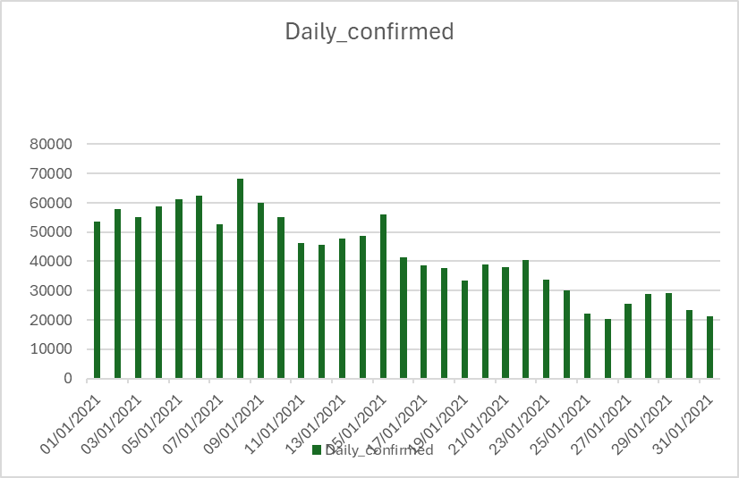**January 2021**

Figure 5.2 – the daily deaths in January 2021

Figure 5.1 - The daily confirmed cases in January 2021

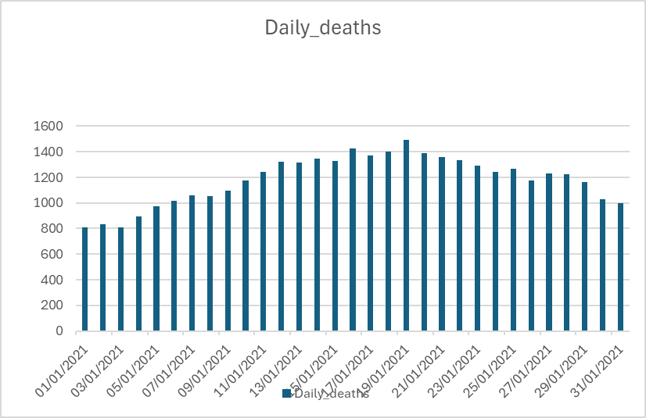

In January 2021 the Alpha variant was in circulation, it had a 70% transmissibility rate compared to the original version. which correlates to the high confirmed rates shown in Figure 5.1. Due to the increase of covid cases and the four-tier system not being able to contain the spread of the variant on the 6th of January the UK entered the third lock down to reduce the number of cases. The social rules for this lockdown were like the first except this time if those are eligible, they could form support bubble and certain gathering were also exempted for the ban. This lockdown resulted in an immediate dip in the number of covid cases on the 7th of January with 52798 as shown in Figure 5.1. However, the number of covid cases increase again the next day and was the peak number of the month before having a steady decrease for the rest of January. Although the lockdown was able to reduce the number of cases by prohibiting larger groups this had no effect on the number of deaths shown by the graph in Figure 5.2. The deaths of the month had a steady increase to the highest value of 1492 deaths on the 19th of January. While comparing the graphs the number of daily confirmed cases is much greater than the daily number of deaths recorded showing that while the number of deaths increase during the lockdown its proportion to the confirmed cases is smaller.

**January 2022**

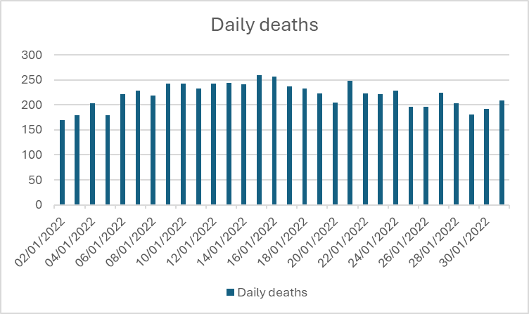

Figure 5.4. - The daily deaths in January 2022

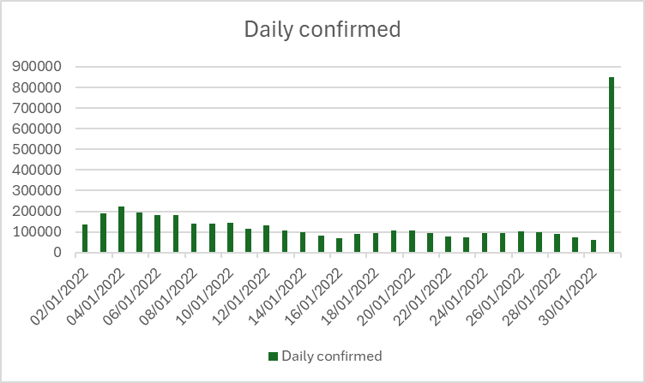

Figure 5.3. - The daily confirmed cases in January 2022

In January 2022 the variant in circulation was an omicron variant which had a transmissibility of 81% by day 5 of symptoms. This correlates to the trends in data shown in Figure 5.3 since the omicron variant was much easier to contract compared to the alpha variant. However, while the number of daily cases is extremely high compared to the previous year the number of deaths has significantly decreased. This could be due to the way cases were talked and cured with 2022 being two years since the original covid citing so multiple vaccine has been released by then to combat the infection and prevent deaths hence why the death rate isn’t as large. At the start of January 2022, the UK was following the Plan B restrictions which was placed in December the previous year to reduce the number of omicron variant infections. This period requires face masks to be compulsory and most people worked from home. Due to the cases slowly decreasing the government decided to return to Plan A restrictions where face masks were no longer compulsory, and people began to commute to work. The graph in Figure 5.3 shows that there is a large spike in cases on the 31st of January with a case number of 848169 which is an error since is doesn’t follow the trend in data shown by the graph. Also, that value doesn’t correlate to the number of deaths shown in Figure 5.4 either. The deaths shown in Figure 5.4 are very consistent with most of the values ranging between 150 – 260 showing the deaths have come to a stable rate. The maximum daily deaths are on the 15th of January with a total count of 260 deaths in comparison to the previous year where the maximum daily deaths were 1492 showing a massive difference between the two. Similarly, the daily confirmed cases are very consistent with values staying between 60000 and 220000. The maximum cases in the month excluding the anomaly are 223828 which is a huge increase from January 2021 which had a peak value of 52798 showing how infectious omicron is compared to alpha.

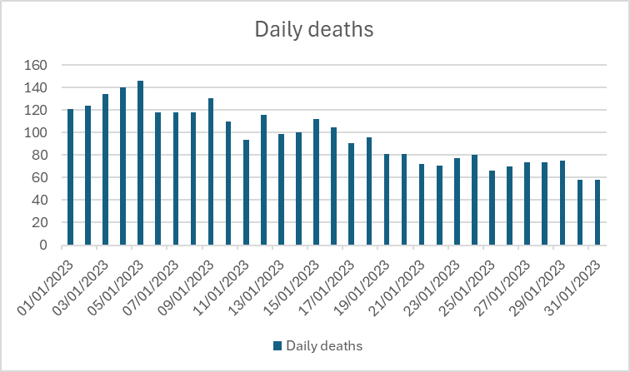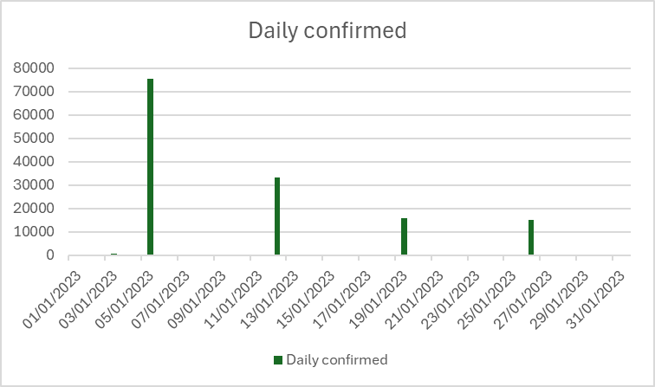**January 2023**

Figure 5.6 - the daily deaths in January 2023

Figure 5.5 - the daily confirmed in January 2023

In 2023 omicron was still the variant being circulated however at this point the severity of Covid had decreased fully so there were no specific regulations to follow. Figure 5.5 shows the confirmed cases for the month but there was a lack of data in the data set so there was no way to create an accurate graph showing the number of cases. This lack of data is mostly likely due to covid no longer being an issue that required data collection, so no importance was given to keep the data up to date with the daily readings. Figure 5.6 shows the daily deaths of the month which shows that the values are beginning to slowly decrease with a maximum of 146 deaths on the 5th of January and minimum of 58 deaths on the 31st of January confirming the analysis of deaths decreasing. Comparing the January data of each of the three years, the daily deaths have decreased each year. The maximum death in January 2023 is around 100 times smaller compared to the originally stated value of 1492 shown in Figure 5.2. Since most people would have had most of the required vaccines and booster most people would easily be able to survive covid without any medical assistance too which could also explain the lack of daily confirmed cases data since most people by this time wouldn’t need to report their infections.

1. **Fiji**

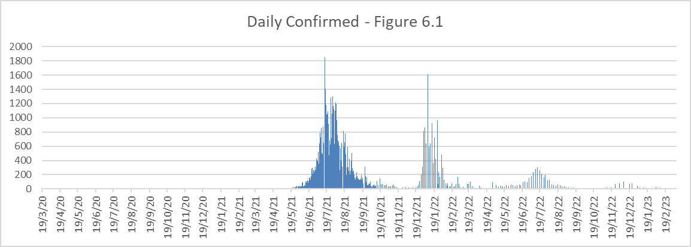

Figure 6.1

For Fiji, Figure 6.1 shows a bar graph demonstrating a great oversite of how the confirmed cases changed over the years. The data was calculated by taking the total confirmed cases column and subtracting the previous days data away from the current days data to obtain the daily rate. During 2020, there were very few confirmed cases suggesting little spread of the disease. The first major spike occurs from June to September of 2021 during the winter, suggesting an increase of contact with Covid-19 and a lack of immunity due to fewer prior cases resulting in the biggest maximum of 1854 cases on the 15th of July. The subsequent peak is between December 2021 and February 2022 which is in the summer for Fiji with a shorter duration and smaller maximum of 1608 cases on the 8th of January. The next spike has a longer duration than the second peak lasting from May to August 2022 with a smaller peak, then a final peak between November 2022 and January 2023 with even fewer cases. This suggests that as time progressed, Fiji became more adept at handling the pandemic leading to smaller peaks, but still having seasonal spikes in the middle of both winter and summer.

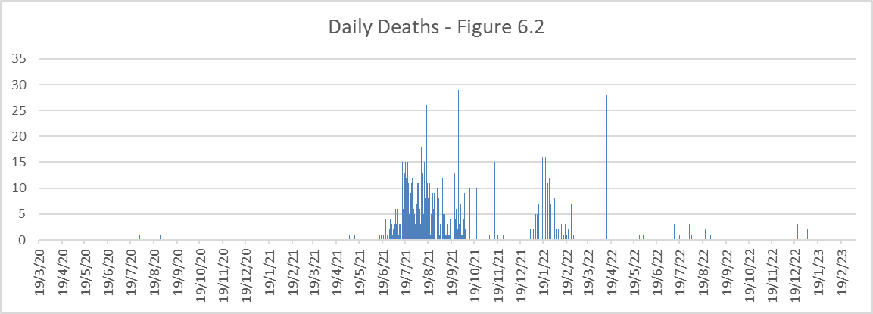

Figure 6.2

Figure 6.2 shows a similar trend of a major peak between June and September of 2021 and another spike December 2021 to February 2022. On the 13th of April 2022, there was a massive spike in deaths over the course of just one day, which seems unrealistic but could have been the effect of Covid-19 on one community. The next little waves also match up with the confirmed cases dates but are much lower suggesting they had more capacity to help people recover from the disease.

|  |  |  |  |  |  |  |
| --- | --- | --- | --- | --- | --- | --- |
| Mean Cases for each month of full data | | | | | | |
| Summer | Confirmed | Deaths |  | Winter | Confirmed | Deaths |
| Apr-20 | 0.43 | 0.00 | May-20 | 0 | 0 |
| Nov-20 | 0.27 | 0.00 | Jun-20 | 0 | 0 |
| Dec-20 | 0.23 | 0.00 | Jul-20 | 0.29 | 0.03 |
| Jan-21 | 0.19 | 0.00 | Aug-20 | 0.03 | 0.03 |
| Feb-21 | 0.14 | 0.00 | Sep-20 | 0.13 | 0 |
| Mar-21 | 0.26 | 0.00 | Oct-20 | 0.06 | 0 |
| Apr-21 | 1.67 | 0.00 | May-21 | 10.35 | 0.06 |
| Nov-21 | 12.17 | 0.73 | Jun-21 | 132.67 | 0.57 |
| Dec-21 | 26.65 | 0.06 | Jul-21 | 818.16 | 7 |
| Jan-22 | 292.65 | 3.23 | Aug-21 | 546.29 | 8.32 |
| Feb-22 | 53.69 | 1.24 | Sep-21 | 143.57 | 4.27 |
| Mar-22 | 15.29 | 0 | Oct-21 | 36.06 | 1.61 |
| Apr-22 | 7.67 | 0.93 | May-22 | 12.03 | 0.06 |
| Nov-22 | 3.70 | 0 | Jun-22 | 23.53 | 0.07 |
| Dec-22 | 10.55 | 0.10 | Jul-22 | 59.23 | 0.13 |
| Jan-23 | 3.81 | 0.06 | Aug-22 | 19.48 | 0.26 |
| Feb-23 | 2.46 | 0 | Sep-22 | 2.97 | 0 |
|  |  |  | Oct-22 | 0.71 | 0 |
| Total Mean | 25.34 | 0.37 | Total Mean | 100.31 | 1.25 |

Figure 6.3

Figure 6.3 is a table of the mean of each month for confirmed cases and deaths. The mean was calculated by summing all the daily values and then dividing by the number of days in the month to get an average for the number of cases in that month. This was then separated into the summer and winter period for Fiji where the change in shade shows the different summer and winter seasons. It also only contains months where there is data for each day of the month. The last row is the mean of all the summer and winter months data. The data shows how there were typically more confirmed cases and deaths in the winter months than the summer period as they have a higher total mean of 100.31 compared to 25.34. The winter months also have a higher maximum mean of 818.16 in June 2021 for confirmed cases and 8.32 in August of 2021 for recorded deaths.

1. **Conclusion**

Overall, In January 2023 the UK and US witnessed improvements in the trends of daily confirmed cases and deaths. This contrasts with the initial stages of the pandemic in mainland China, where there was a gradual increase in the number of cases followed by a sharp spike and subsequent decline. The emergence of the omicron variant, with its higher infection rate compared to the alpha variant contributed to the increase in cases in January 2022 compared to the previous year. Additionally, in Fiji, the winter months saw more cases on average for both deaths and confirmed cases. Each spike in cases and deaths seemed to occur in either in the middle of summer or winter.

1. **Appendix**

All programmes and condensed data for the creation of the graphs and analysis of the data can be found on GitHub using the link:

<https://github.com/lillypuff88/Data-Science-Practice-Group-Project->